Business Question and Visualization Report

Date | 18 July 2026
Team ID | Sharmishtha Mishra
Project Name | HeartScope
Maximum Marks | 5 Marks

Q1: What are the primary performance indicators across delivery fees, order values, customer ratings, and order volumes?
- Visualization: A KPI Demonstration table showcasing aggregated metrics (SUM(Delivery Fee), SUM(Order Value), AVG(Rating Given), and CNT(Order Id)).
- Insight Provided: Provides stakeholders with a high-level executive summary of overall platform scale, total revenue generation, cumulative delivery earnings, and average customer satisfaction at a glance.
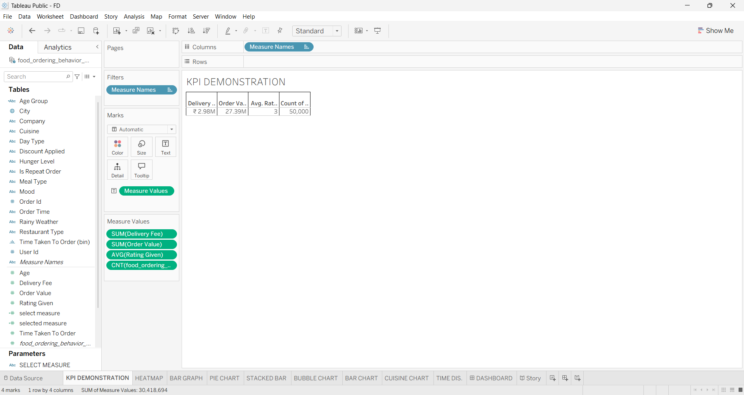

Q2: How does customer satisfaction (average ratings) vary across different combinations of hunger levels and consumer moods?
- Visualization: A Heatmap matrix mapping customer moods against hunger levels, color-coded by average rating values.
- Insight Provided: Highlights which emotional and physiological states correspond to higher or lower customer satisfaction, enabling targeted experience optimizations for stressed or hungry users.
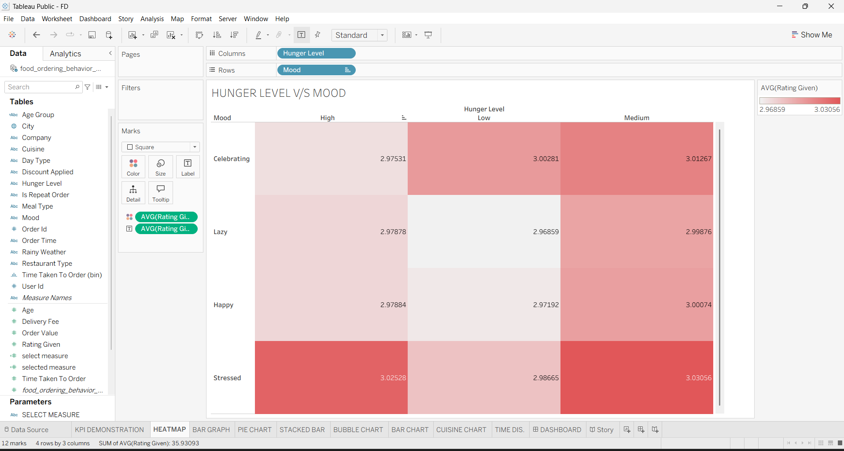

Q3: How are order volumes distributed across different age groups broken down by restaurant types (Budget, Mid-range, Premium)?
- Visualization: A grouped Bar Graph showing order counts across consumer age categories segmented by restaurant price tiers.
- Insight Provided: Identifies target demographic segments (such as Gen Z and Millennials) and their preferred dining tiers, guiding platform marketing and restaurant partnership strategies.
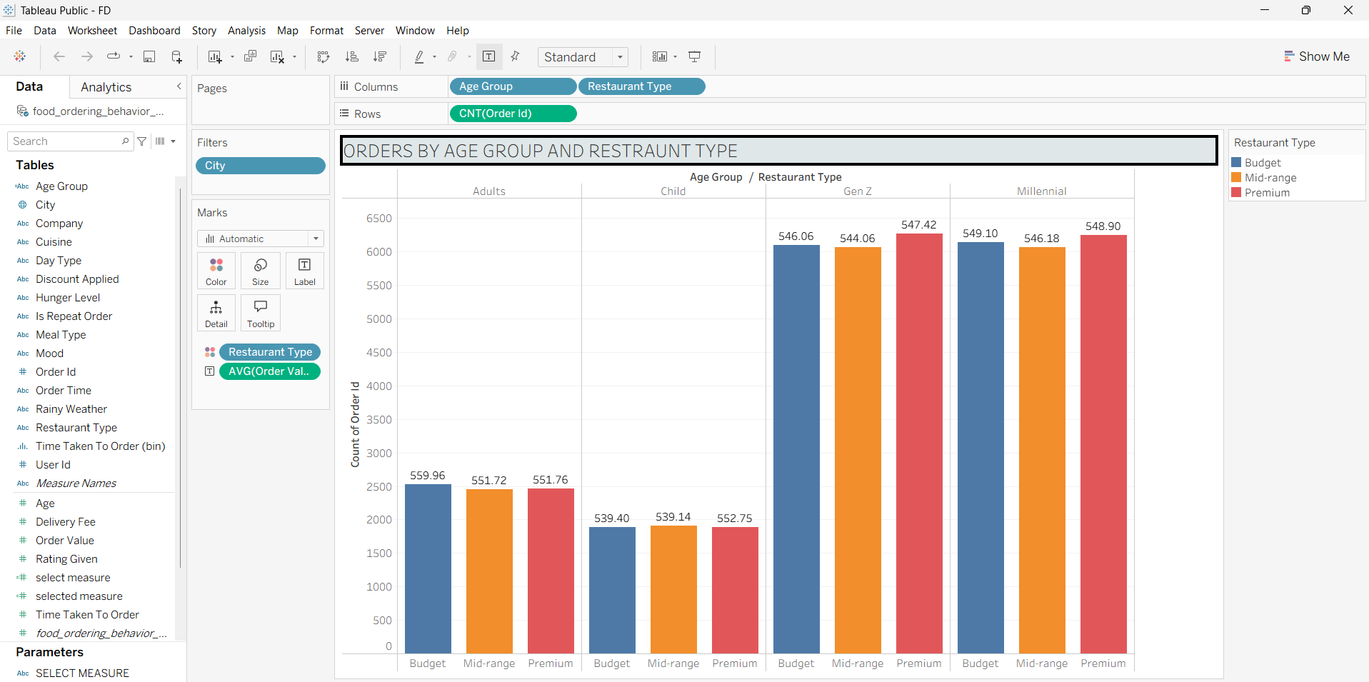

Q4: What is the percentage share of total orders distributed among various culinary preferences?
- Visualization: A proportion-based Pie Chart illustrating the order share across different cuisine types (e.g., Biryani, Chinese, Desserts, Fast Food, North Indian, South Indian).
- Insight Provided: Quickly displays consumer cuisine popularity, helping platform managers balance restaurant onboarding and promotional campaigns.
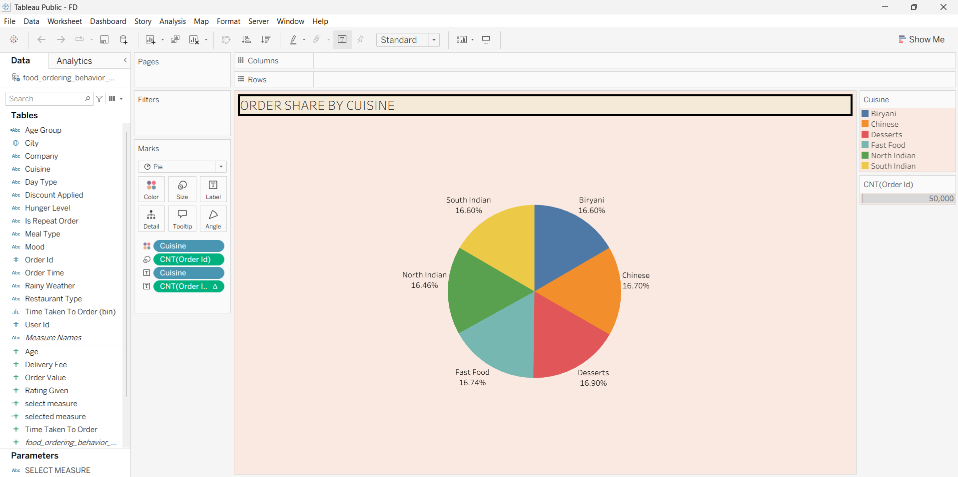

Q5: How is total order value distributed across different metropolitan cities, and what is the impact of discount applications?
- Visualization: A Stacked Bar Chart comparing total order values across cities (Bangalore, Chandigarh, Delhi, Hyderabad, Mumbai, Pune), segmented by whether discounts were applied.
- Insight Provided: Evaluates regional revenue contributions and demonstrates how promotional discounting influences overall spending volume across urban markets.
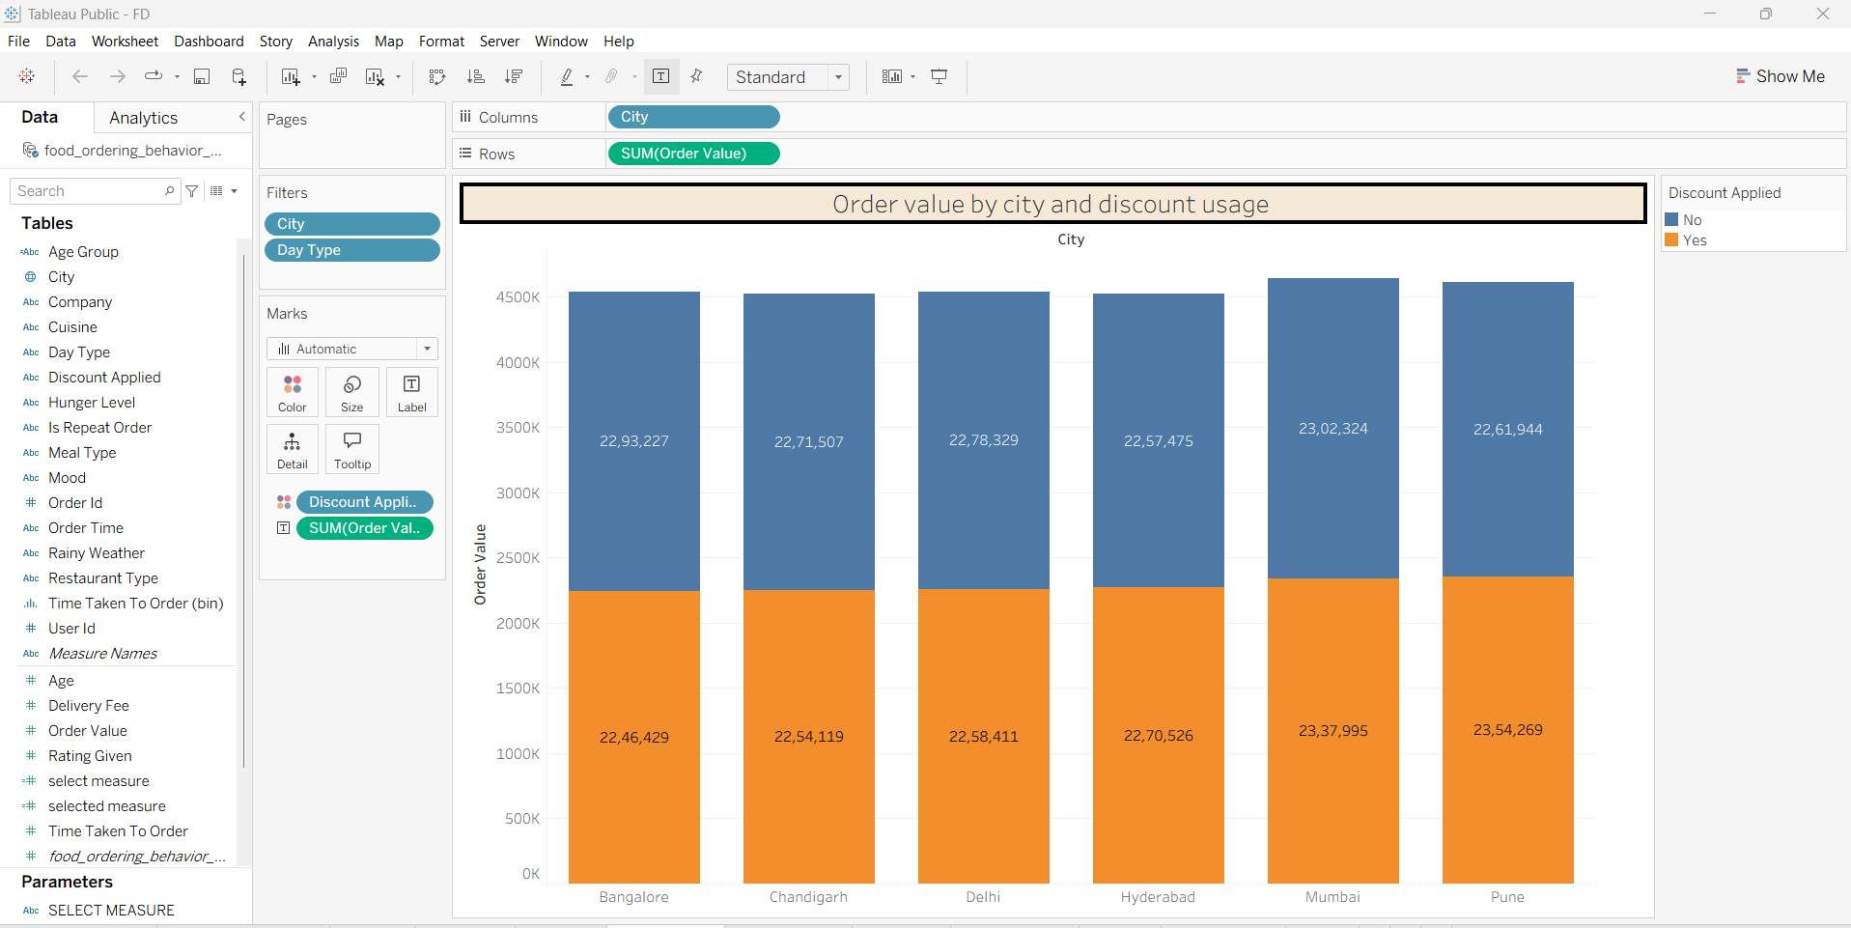

Q6: What is the relative popularity and order volume distribution among different cuisine categories?
- Visualization: A Bubble Chart where each bubble represents a cuisine type sized and labeled by its total order count.
- Insight Provided: Visually emphasizes leading food categories within the ecosystem, providing an intuitive comparison of relative demand across menu types.
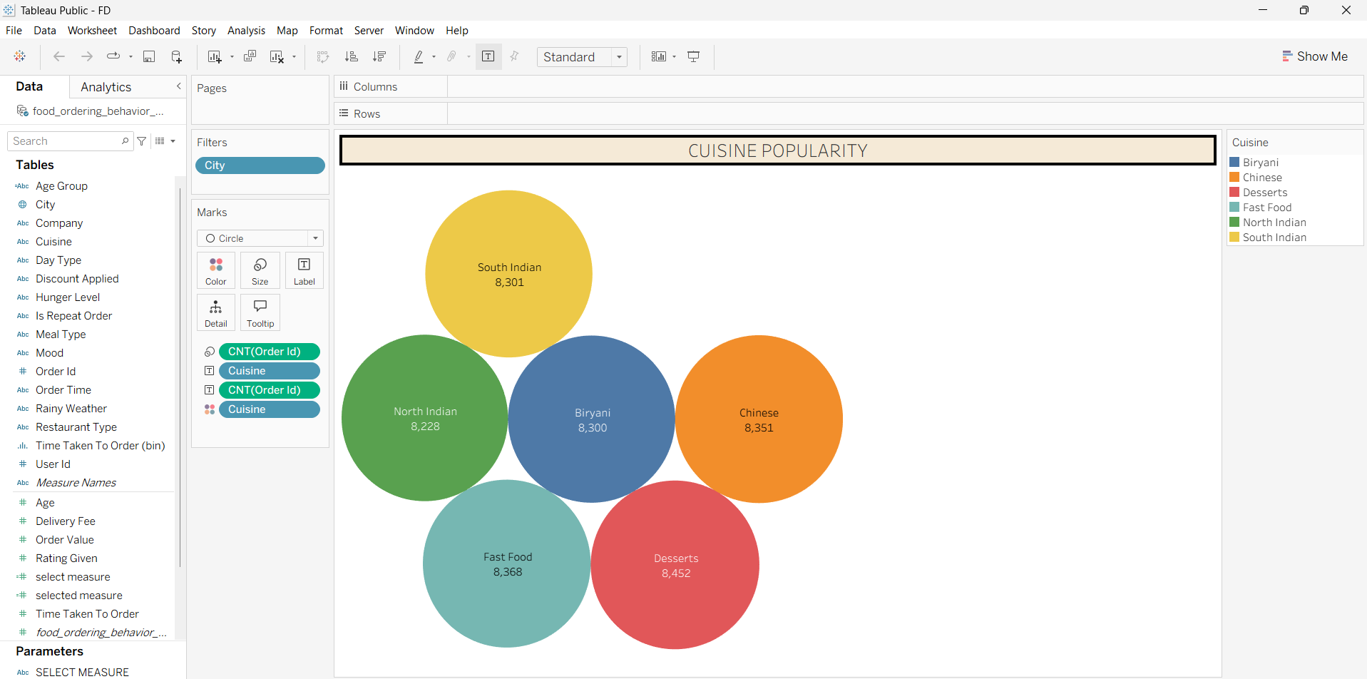

Q7: How do consumer order counts fluctuate under different weather conditions (Rainy vs. Non-Rainy) combined with customer moods?
- Visualization: A comparative Bar Chart mapping order frequency across mood categories split by rainy weather status.
- Insight Provided: Uncovers environmental and psychological drivers of food delivery demand, demonstrating how weather shifts influence ordering volume during specific moods (e.g., Stressed or Celebrating).
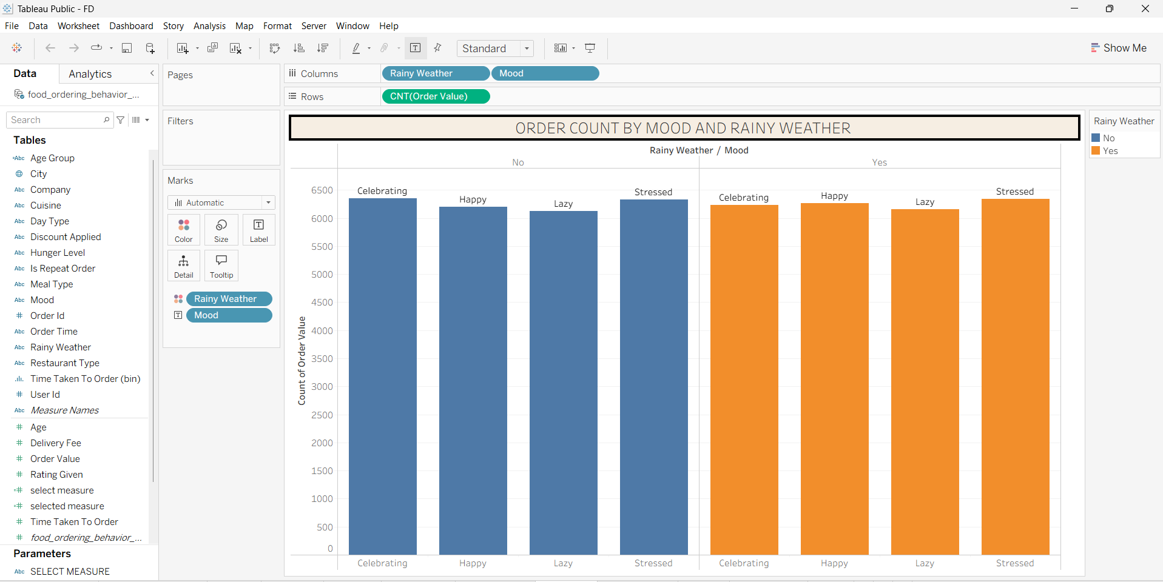

Q8: How does cuisine-wise revenue or order distribution shift when evaluated against selectable custom parameters?
- Visualization: A dynamic Bar Chart mapping cuisines against a selectable measure parameter (CNT(select measure) / Revenue).
- Insight Provided: Offers flexibility for analysts to dynamically toggle performance metrics across food categories to evaluate revenue generation versus order frequency.
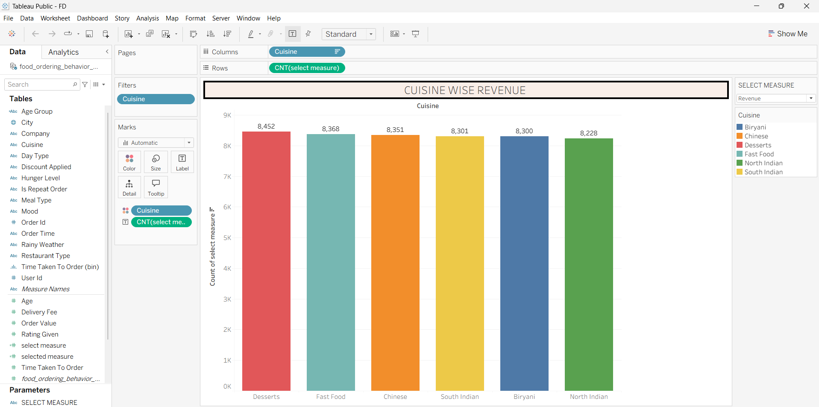

Q9: What is the distribution pattern of decision-making time taken by users before placing an order across different cities and meal types?
- Visualization: A distribution Bar Chart illustrating the count of orders binned by the time taken to order.
- Insight Provided: Helps operations teams understand user browsing behavior and decision friction, optimizing app interface responsiveness and recommendation speed.
